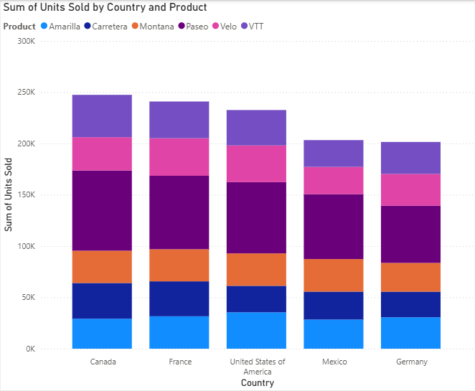

* **Chart Type** **: Stacked column Chart**
* X-Axis : Country (Categorical Data)
* Y-Axis : Sum Of Units Sold (Numerical Data)
* **INSIGHTS FROM THE CHART**
* Overall Sales By Country :
* Canada has the highest total units sold , followed by France.
* USA is slightly lower than France .
* Mexico and Germany record comparatively smaller sales.
* **Product Contribution:**
* Montana appears to be the largest contributor , forming the biggest portion of the stacked column.
* Amarilla and Carretera also contributes significantly but vary more across countries.
* VVT and Velo make smaller contributions , indicating they are less popular products.